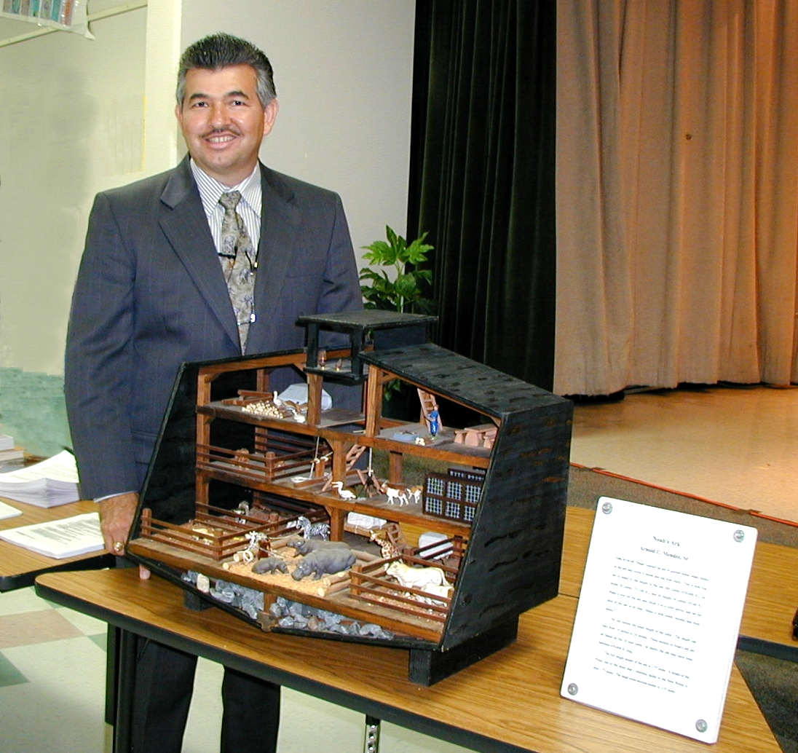
Arnold Mendez, a UCG Elder, has presented the Noah's Ark and Early Man seminars in more than 90 UCG congregations (www.ucg.org) and at Ambassador Bible Center. He has studied the Genesis account and the creation evolution controversy for the last 30 years. He is a chemistry instructor at Texas A&M University-Corpus Christi. He has both a Master and Bachelor of Science degree in Biology (minor Chemistry) and was a former research and graduate teaching assistant at the university level.

Seminar Format
The Seminar presentation is usually scheduled for a double Sabbath service. Two formats are popular. The first format is a double seminar presentation. This includes a Noah's Ark Seminar in the morning and an Early Man Seminar in the afternoon. The second format is a either a Noah's Ark Seminar or an Early Man Seminar presentation in the morning and a sermon in the afternoon. If the second format is selected it is recommended that the Noah's Ark Seminar/Sermon be presented initially and then at a later date the Early Man Seminar/Sermon can be presented. Many congregations combine services with a sister congregation and usually have a luncheon break at noon.

Arnold would be happy to present these seminars/sermons in your church area. They are ideal for Youth Sports weekends, Young Adult weekends, and combined local Sabbath services. They are of interest to all church members of whatever age. These seminars are presented at cost and usually require the host church to provide transportation, Sabbath housing with a church family, printing, and associated costs, etc. References from UCG pastors can be provided.

If you feel your Church could benefit from one of these presentations please forward this brochure to your minister or activity coordinator.

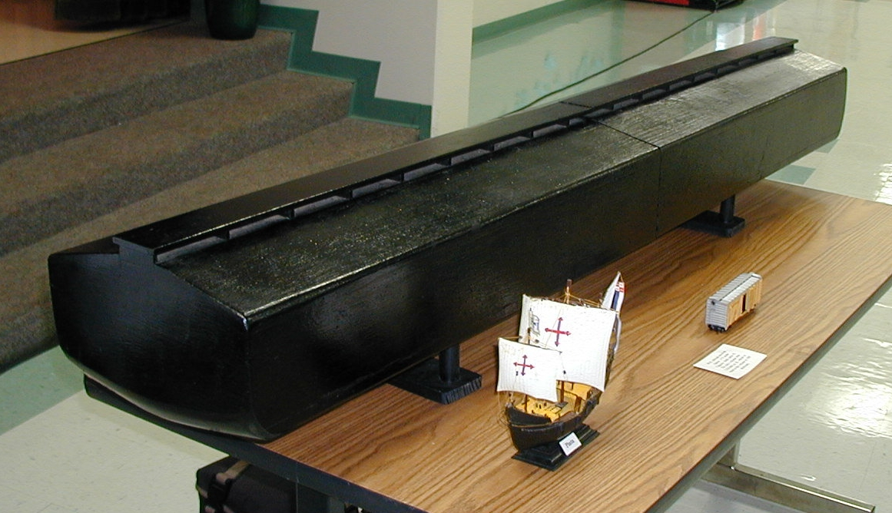
Noah's Ark Seminar:
- Includes various scale models of Noah's ark.
- Poster displays of the geological evidence of the Biblical flood.
Topics Include:
- The flood of Noah—can we believe the Bible?
- Could the ark carry all the animals?
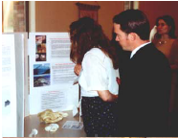
- What did the ark look like?
Early Man Seminar:
- Includes poster displays of evolution/creation topics.
- Displays of relevant fossils and crania (skulls).
Topics Include:
- Who were Homo erectus, Neanderthal man, and Australopithecus?
- Did Pre-Adamic man exist?
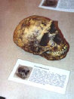
- The antediluvian world and its effects on humans.

Contact Information:
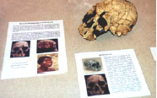
Arnold C. Mendez, Sr.
222 Pearse Dr.
Corpus Christi, TX 78415
Cell (361) 442-8144
Email: acm@amendez.com
Web page: http://www.amendez.com

Noah's Ark† & Early Man Seminar* Locations and Dates

Corpus Christi, TX, Youth Bible Study †  UCG Teton's Challenger Camp†  San Antonio, TX †  Houston South, TX †  Edmond & Oklahoma City, OK †  Tulsa, OK †  Ft. Worth, TX †  Lovington, NM & Odessa, TX †  Corpus Christi & Harlingen, TX †  Austin, TX †  Amarillo & Lubbock, TX †  Victoria, TX †  Acapulco, Mex. (Tabernacles) †  Waco, TX †  Akron-Youngstown, OH †  Cincinnati, OH Winter Weekend †  Orlando, FL †  Waco, TX (Central Texas COG) †  Houston North, TX †  Portsmouth, OH †  Nashville, TN †  Dallas South & North, TX †  Canton, IL †  Nashville, TN *  Akron-Youngstown, OH *  Big Sandy (Independent CoG) †  Big Sandy (Independent CoG) *  St. Petersburg-Tampa, FL †  Terre Haute-Lafayette, IN †  Bethlehem, Harrisburg, Lewistown, PA*†  Giving and Sharing (Phone Broadcast)†  Minneapolis, MN (Building Bridges) †  Eugene, OR †  Terre Haute-Lafayette, IN *  Lexington, KY Winter Weekend 2002 *  Spokane, Coeur d'Alene, WA†  East Texas (Big Sandy, Gilmer,  Gladewater, Tyler, Texarkana)†  Giving and Sharing (Phone Broadcast)*  Williamsburg, VA†  New Orleans-Slidell, LA†  Boston-Worcester, MA†*  Sacramento, CA-Reno, NV† | 6-16-99  8-7-99  1-8-00  3-11-00  5-26-00  5-27-00  6-3-00  7-15-00  8-19-00  8-26-00  9-9-00  9-16-00  10-16-00  11-4-00  11-18-00  12-20-00  1-2-01  2-3-01  2-10-01  4-21-01  5-12-01  6-23-01  7-14-01  11-17-01  12-22-01  1-19-02  2-9-02  3-23-02  4-27-02  8-10-02  10-19-02  11-9-02  11-30-02  12-21-02  12-28-02  1-18-03  2-8-03  2-15-03  2-22-03  3-8-03  3-29-03  4-26-03 | St. Paul-Minneapolis, MN†  Indianapolis, IN†*  Calgary, Alberta Canada†*  Giving and Sharing (Phone Broadcast)†*  Prescott Valley, AZ (Building Bridges)/Northern Arizona (UCG)†  Corpus Christi, TX†  Austin-Waco, TX†*  Portland, OR*†  Lexington, KY Winter Weekend 2003†  Coleman, TX*†  Phoenix AZ (Building Bridges) †*  West Palm Beach-Miami, FL †*  Corpus Christi, TX*  Louisville-Henderson, KY†*  Flint-Detroit-Ann Arbor-Lansing-Kalamazoo-Grand Rapids, MI†  Columbus-Cambridge, OH†*  Ambassador Bible Center  Cincinnati, OH†*  Garden Grove, CA†*  Guanajuato, Mex. (Tabernacles) *  Birmingham-Gadsden, AL†*  UCG Family Winter Weekend 2004*  Ambassador Bible Center  Cincinnati, OH*  Cincinnati, OH†  St. Louis-Kansas City-Columbia, MO†*  Charlotte, Asheboro, Greensboro,  Hickory, Raleigh, NC and Columbia,  Augusta, Florence SC†*  Minneapolis, MN (Building Bridges) †*  Toronto-Ottawa-Hamilton-  Buffalo, Canada†*  Denver-Loveland-Colorado Springs, CO  Phoenix, AZ & Northern Arizona†* | 5-17-03  6-14-03  7-5-03  7-19-03  8-2-03  8-23-03  9-6-03  11-22-03  12-27-03  1-10-04  1-17-04  3-13-04  3-27-04  4-24-04  6-19-04  7-24-04  7-22,23-04  8-21-04  10-06-04  11-20-04  12-25-04  3-17,18-05  3-19-05  3-26-05  5-20-06  6-10-06  7-01-06  8-4-07  8-11-07

